ADVANCED PLAYWRIGHT PROJECT REPORT

Project Objective:
The primary objective of this project was to develop a reusable Playwright automation framework capable of handling both UI and API testing while following good automation practices.
The main goals of the project were:
- Build reusable custom fixtures to reduce repetitive code.
- Implement structured logging using Winston.
- Generate correlation IDs for every test execution.
- Collect artifacts such as screenshots, traces, videos and diagnostic files.
- Perform refund validation using API helper methods.
- Verify both API responses and UI behaviour.
- Improve debugging by collecting useful evidence.
- Organize the project using a clean folder structure.Instead of creating a framework that simply executes test cases, the objective was to build a projects.

App Fixture
The app.fixture.ts file contains reusable helper methods that are mainly used for refund-related scenarios. Instead of writing API requests directly inside every test, I moved them into this file so that the tests focus only on the business validation.

Diagnostic Fixture
The diagnostic.fixture.ts file was created to improve debugging. During automation, failures are common, and simply knowing that a test failed is usually not enough. I wanted every test to produce meaningful logs that could explain what happened during execution.
For every test, this fixture automatically generates a unique correlation ID using Node.js crypto utilities. The correlation ID is then added to the request headers and included in every log entry.

Project Folder Structure:

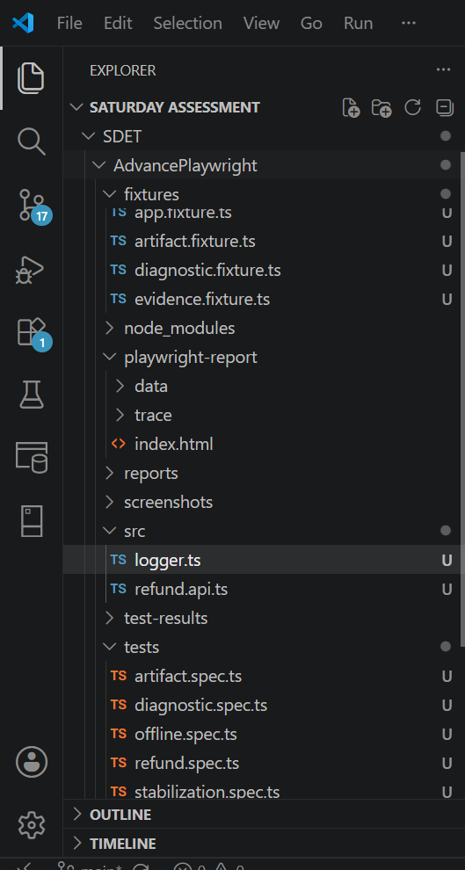

Artifact Fixture
While working on the project, I realized that logs alone are not always enough to investigate failures. Sometimes it is necessary to view the API response or additional diagnostic information.
To solve this, I created the artifact.fixture.ts file.
This fixture creates an evidence object that can store any information collected during test execution. For example, I used it to save cart responses and diagnosis notes during artifact-related tests.
TESTS
1.artifact.spec.ts

Flaky Test Analysis:
The purpose of this test was to simulate a flaky scenario where the UI and the backend are temporarily out of sync. The test compares the cart total displayed in the UI with the cart total returned by the API immediately after updating the cart.
During execution, the assertion failed because the UI had not finished updating while the API had already returned the latest cart value. This created a temporary synchronization issue between the frontend and backend.

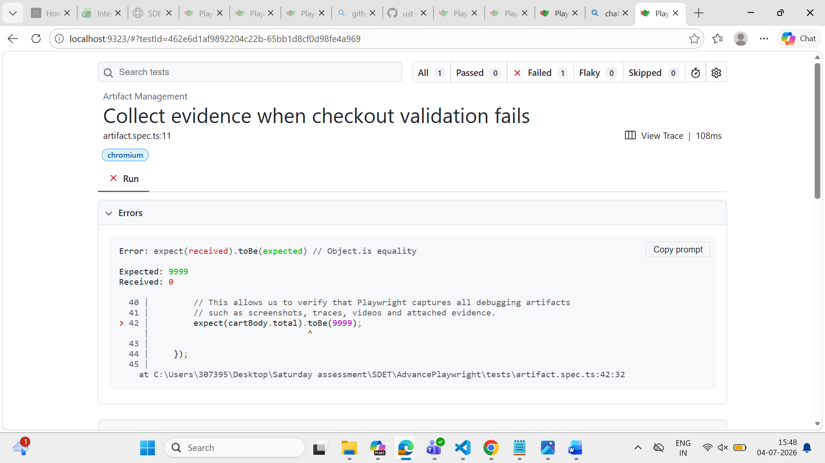
Since this string contains the currency symbol and comma separator, JavaScript could not convert it directly into a number. As a result, Number() returned NaN, causing the assertion to fail.
I fixed the test by replacing the hardcoded assertion with actual validation based on the API response. Instead of expecting an incorrect value (9999), I verified that the cart total is a valid non-negative number and that the response contains the expected data structure. This makes the test validate the application's behavior instead of failing intentionally
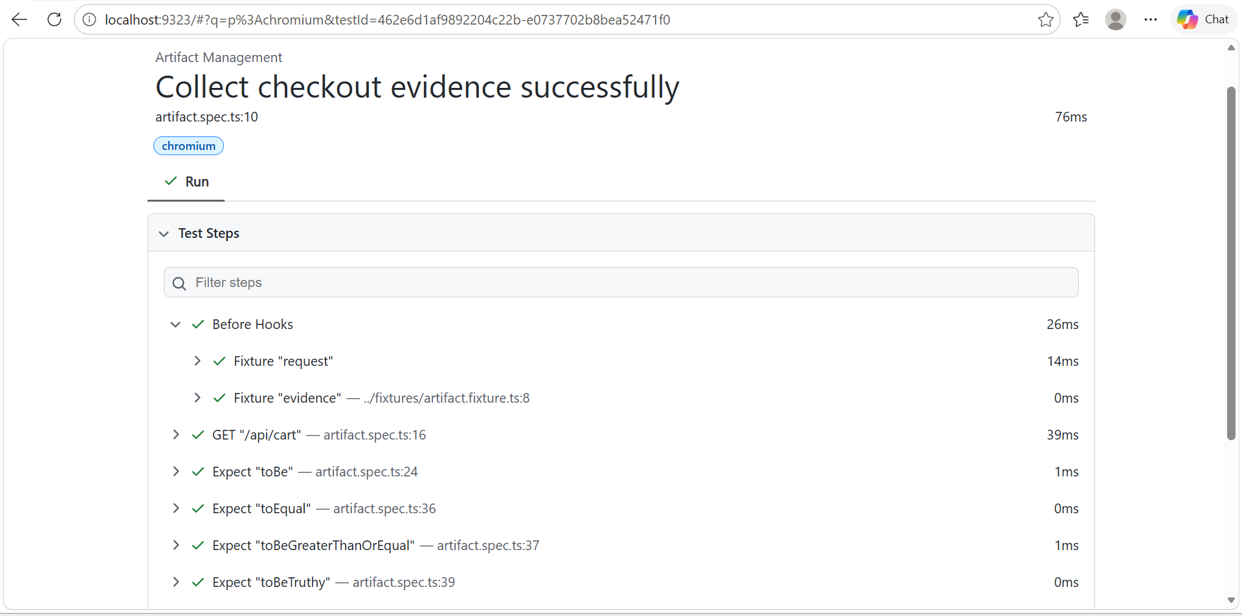
2. diagnostic.spec.ts
- Generated a unique cart session for every test to ensure test isolation.
- Used a correlation ID to uniquely identify and trace a single test execution.
- Logged the start of the test using the correlation ID.
- Sent an API request to add a product to the cart.
- Validated that the Add to Cart API returned HTTP 201 (Created).
- Logged a message after successfully adding the product to the cart.
- Retrieved the cart details using the Cart API.
- Validated that the Cart API returned HTTP 200 (OK).
- Verified that the cart contained exactly one item.
- Logged a successful cart verification message.
- Logged the completion of the test using the same correlation ID.
- Used structured logging to record important events during the checkout journey.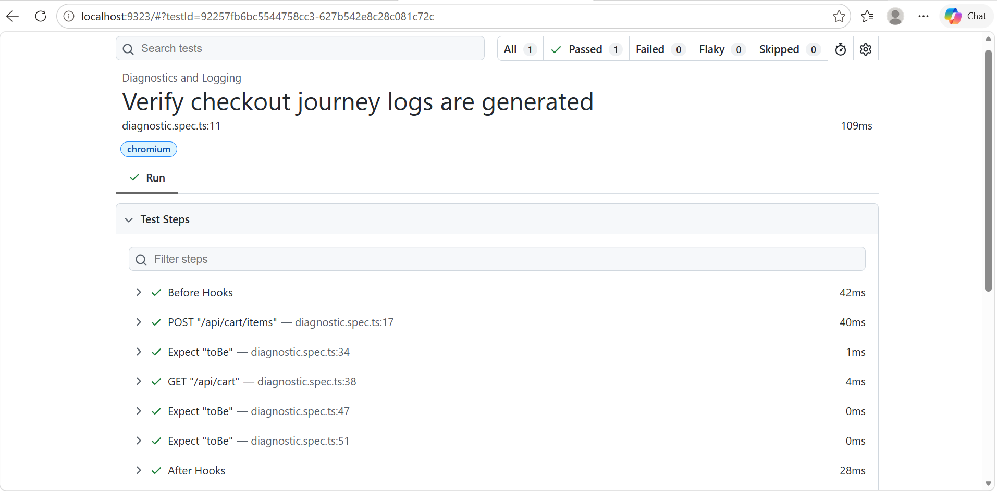 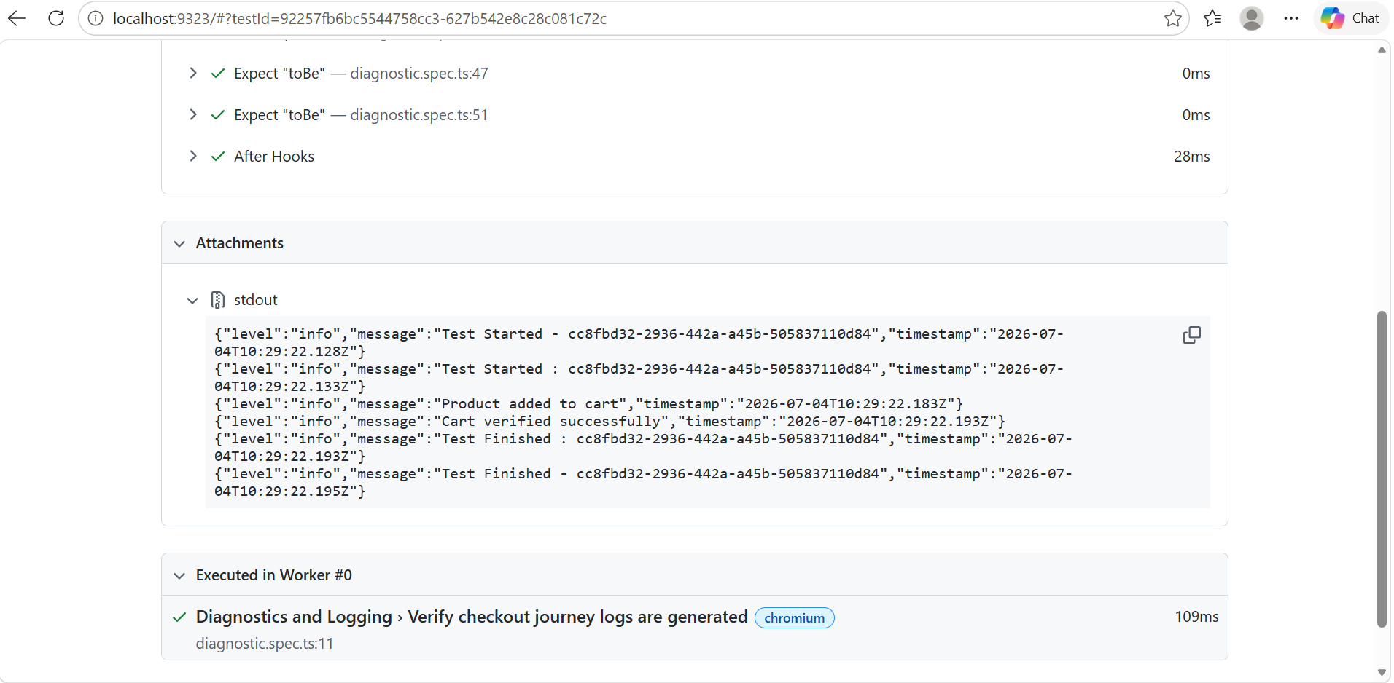
3.offline.spec.ts
Test 1: Verify application when network is offline
- Opened the application using Playwright.
- Simulated offline mode using page.context().setOffline(true).
- Refreshed the application while the network was unavailable.
- Verified that the browser was actually offline by checking navigator.onLine.
- Logged a message confirming that the application was running in offline mode.
- Restored the network connection after completing the validation.

Test 2: Verify application works after network is restored
- Simulated a network disconnection.
- Restored the network connection.
- Opened the application after reconnecting to the network.
- Verified that the application loaded successfully.
- Confirmed that the application was accessible after the network was restored.
- Logged a success message indicating that the application recovered correctly
TEST1 RESULTS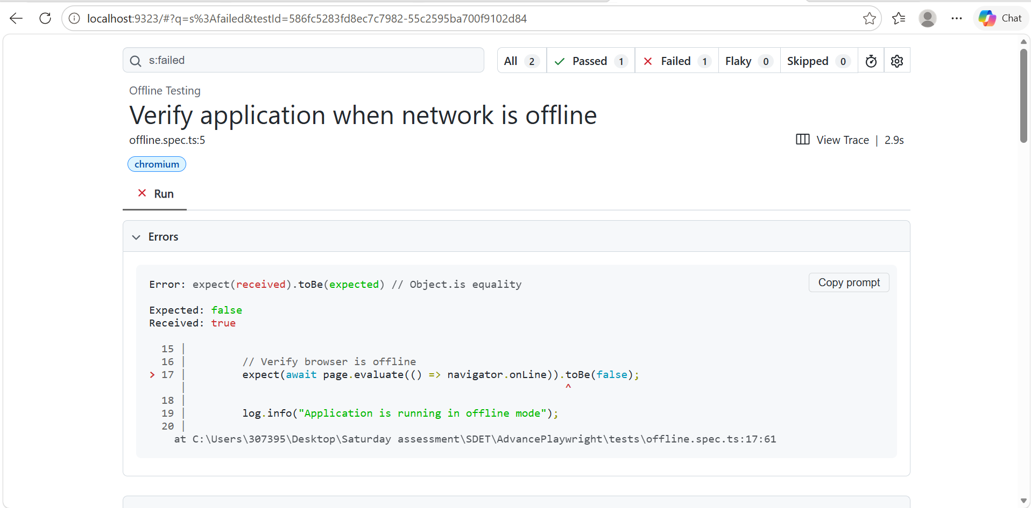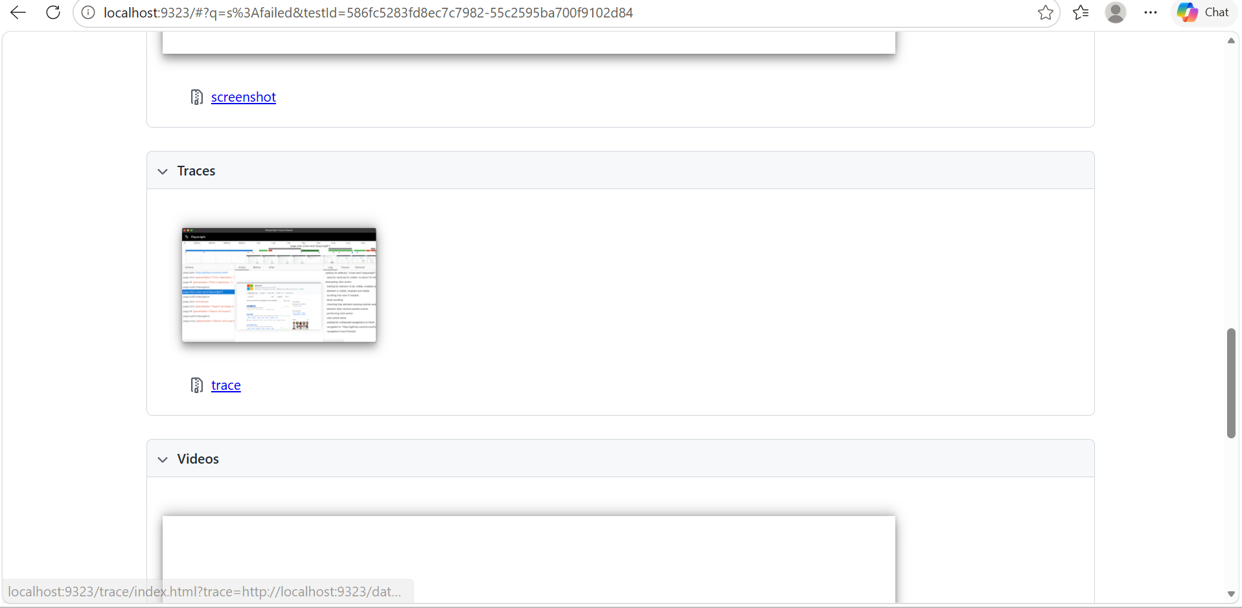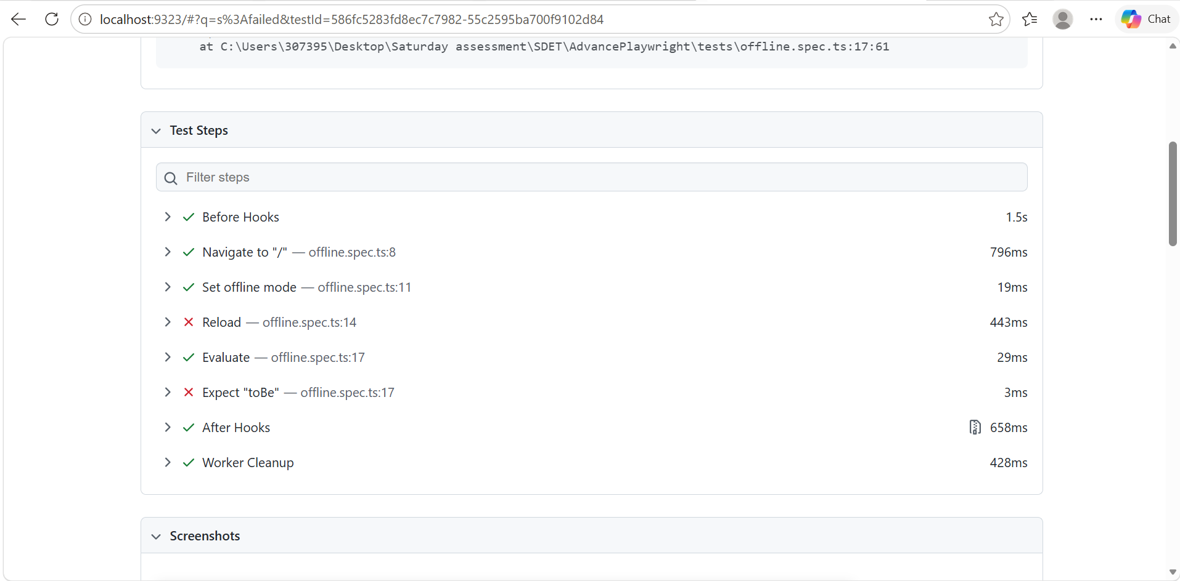TEST2 RESULTS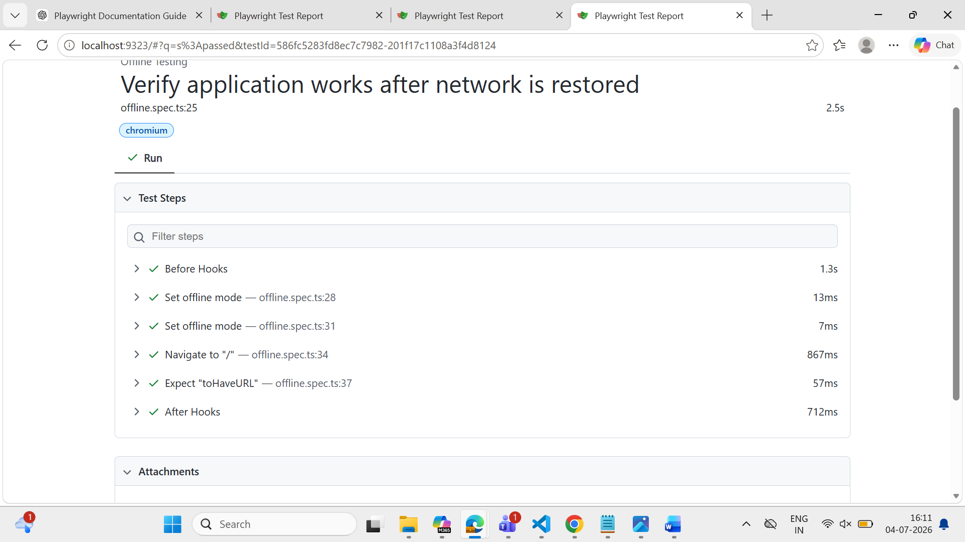
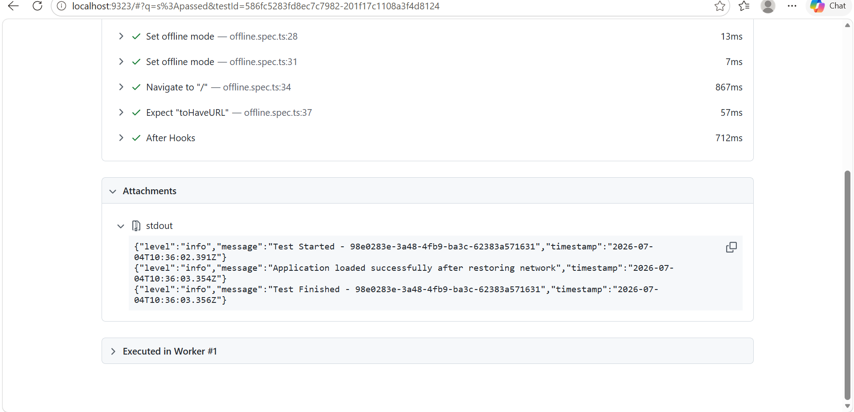

4.refund.spec.ts
1. Verify Partial Refund
This test verifies that a customer can partially refund an order. I first created a new order, processed a refund for one item, and then checked that the refunded amount, order status, and refund count were updated correctly. Finally, I confirmed that only a partial refund was recorded.
2. Verify Full Refund
This test validates the complete refund process. I created a new order, refunded all the items, and verified that the total refund amount was correct. I also checked that the order status changed to REFUNDED, the refundable balance became zero, and the Returns page displayed the updated refund details.
3. Verify Valid Refund Eligibility
This test checks whether a refund request is eligible before it is processed. After creating an order, I requested a refund for a valid quantity and verified that the system approved the request. This ensures that only valid refund requests are accepted.
4. Verify Over Refund is Rejected
This test verifies that the application prevents over-refunding. I attempted to refund more items than were originally purchased and confirmed that the system rejected the request with an OVER_REFUND verdict. This helps prevent incorrect refund transactions.
5. Verify Idempotent Refund
This test ensures that duplicate refund requests do not create multiple refunds. I generated a single idempotency key and used it for two identical refund requests. The system returned the same refund ID for both requests and recorded only one refund, confirming that duplicate requests are handled safely.
6. Verify Different Idempotency Key Creates Another Refund
This test verifies that different idempotency keys are treated as separate refund requests. I sent two refund requests using different idempotency keys and confirmed that the system created two separate refunds. This shows that only identical requests with the same key are prevented from being processed multiple times.

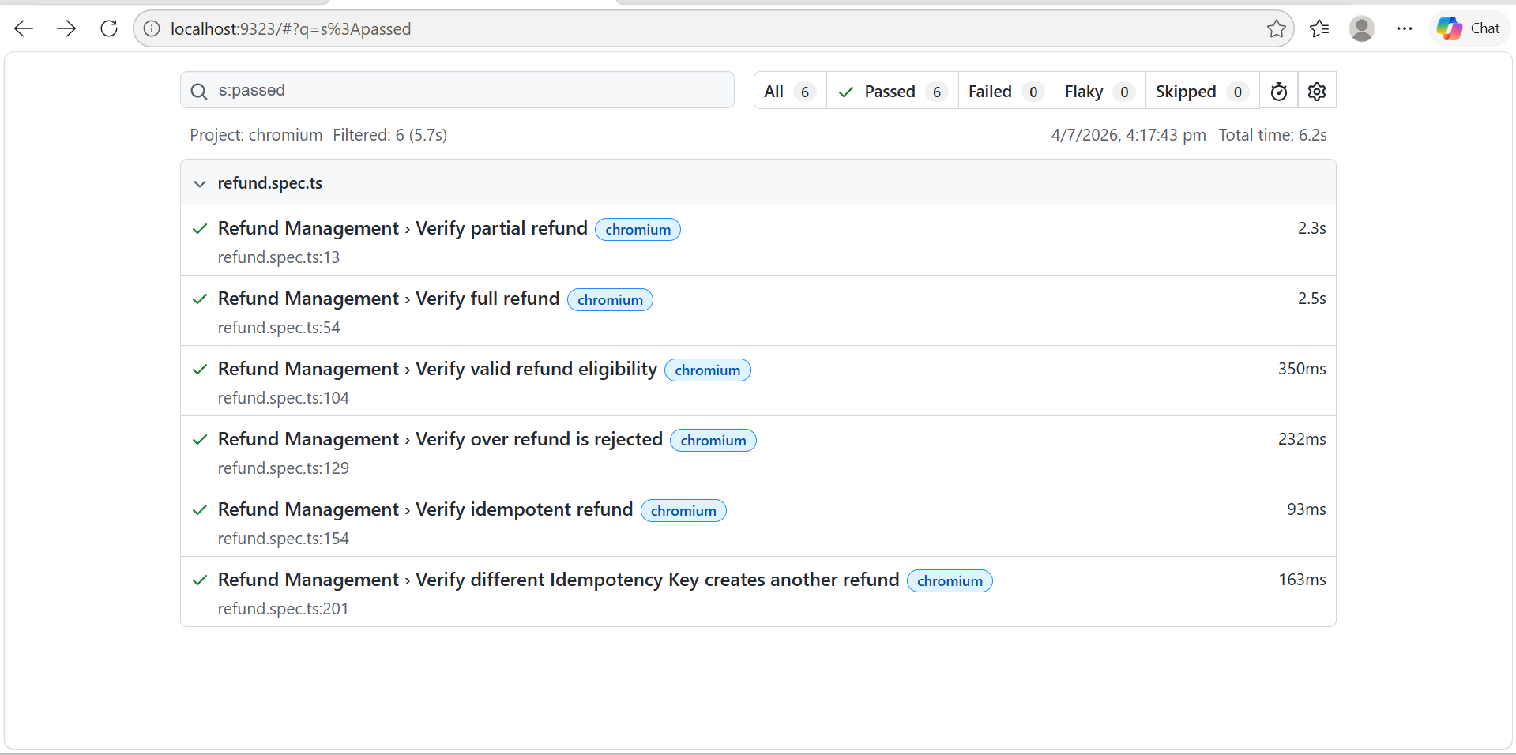
4.flaky.spec.ts
The test was flaky because the UI value was read before it finished updating
Root Cause: There was a race condition between the simulated backend update and the UI rendering.
Fix: I waited for the UI synchronization before performing the assertion.
Verification: I executed the same test 50 times before and after the fix. Before the fix, the test failed intermittently. After the fix, all 50 executions passed.

Test1: flaky results

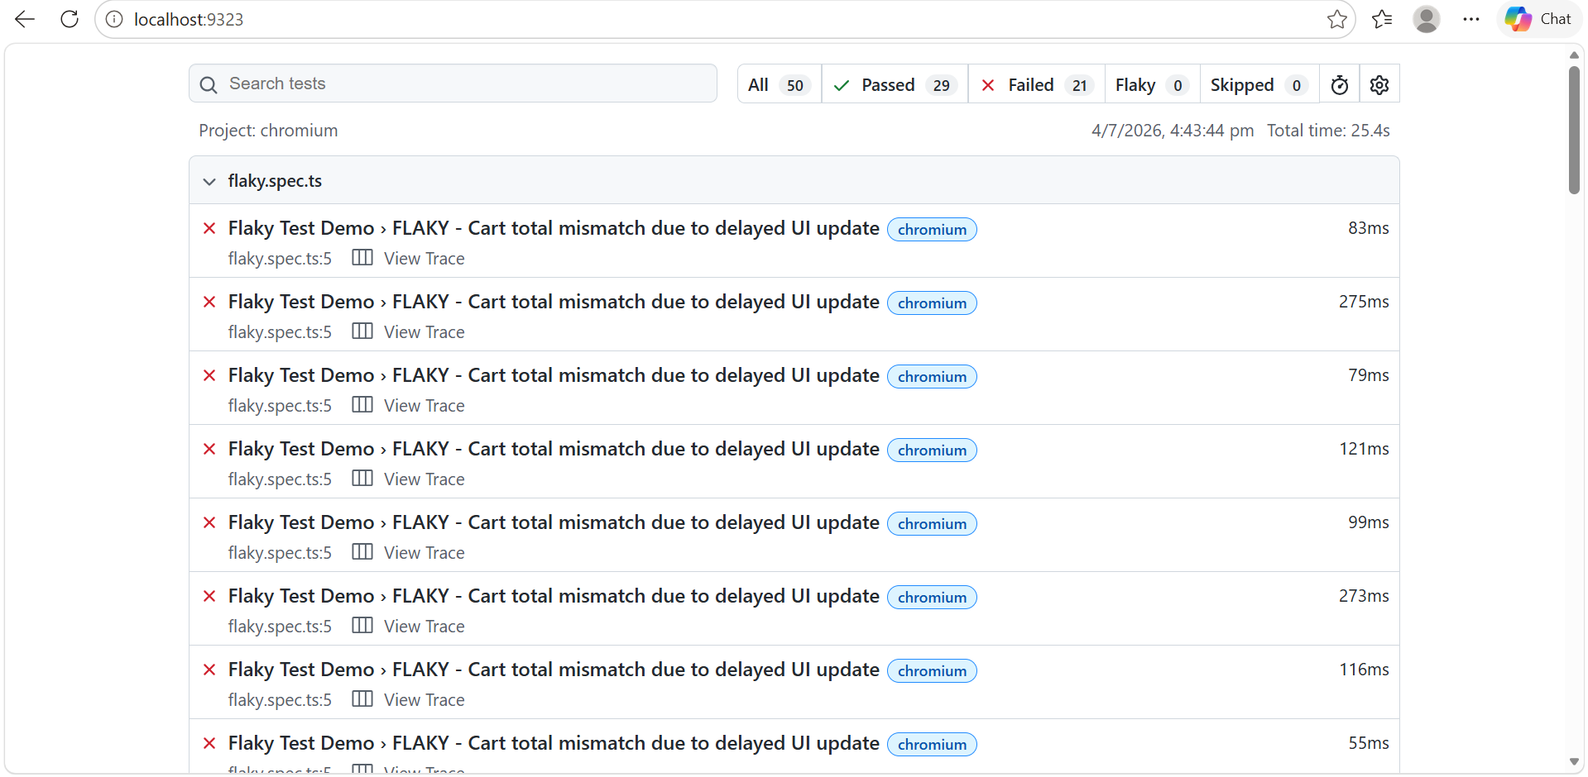

Test2: non-flaky results
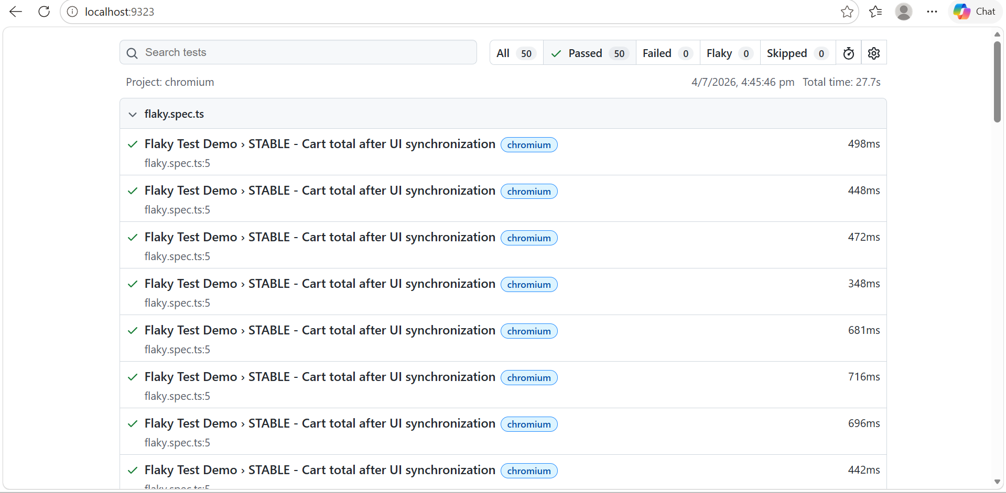

5.stabilization.spec.ts

stabilization.spec.ts file is demonstrating how to stabilize Playwright tests by waiting for the application to reach the correct state before making assertions. It is not testing business logic like refunds or login—it is testing good synchronization practices to avoid flaky tests.

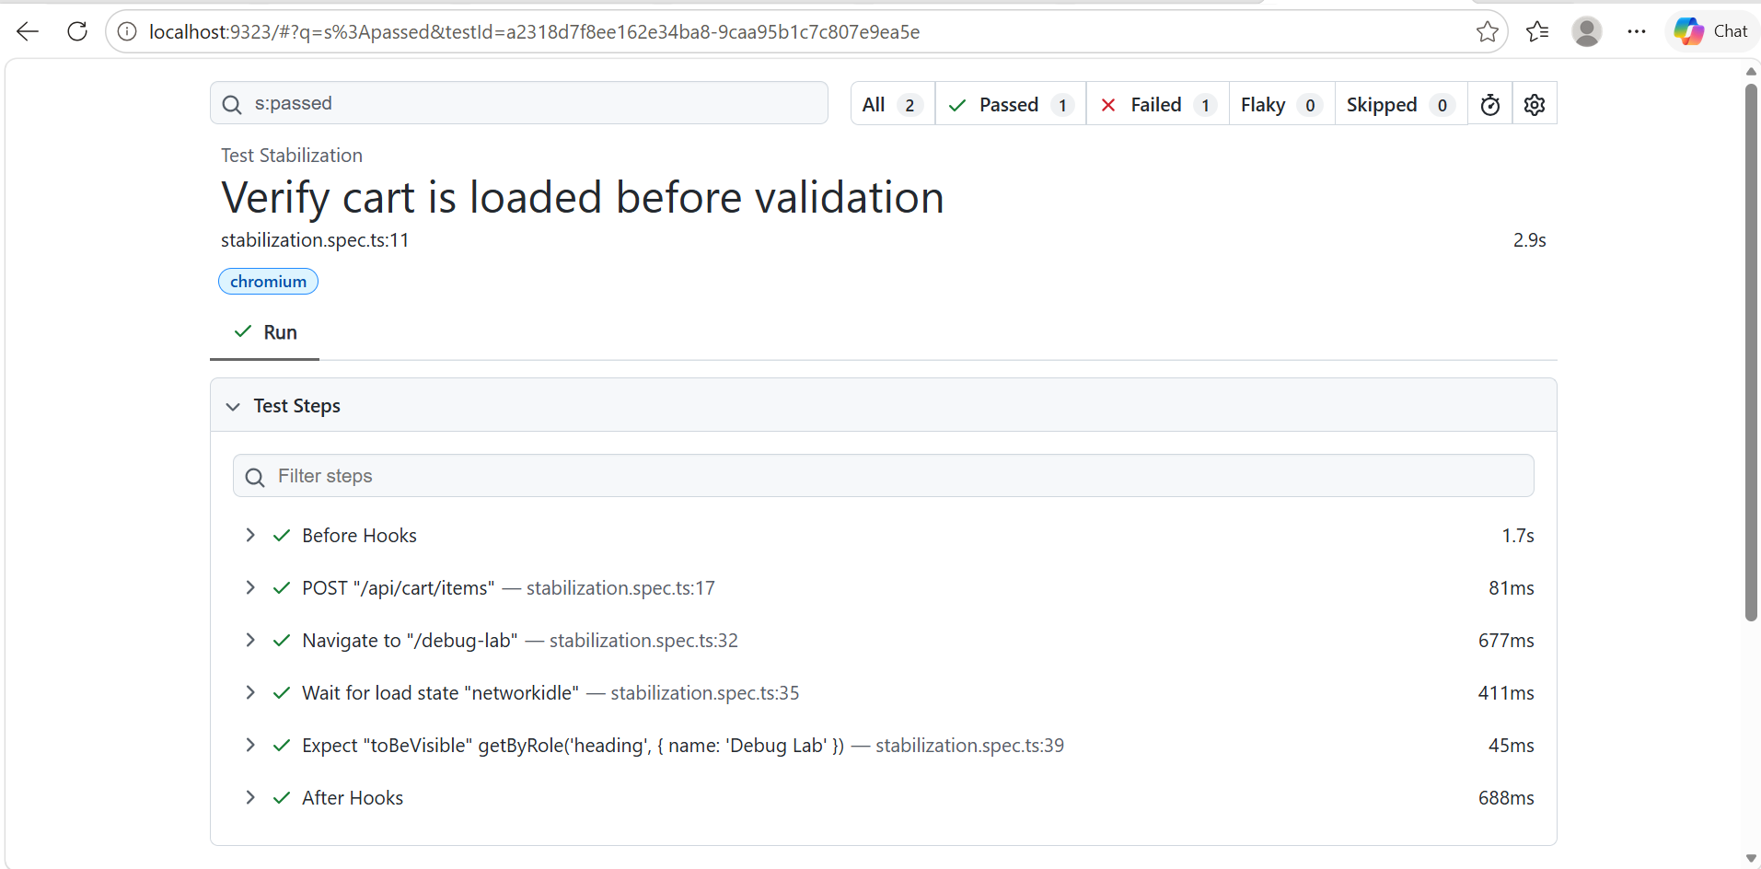
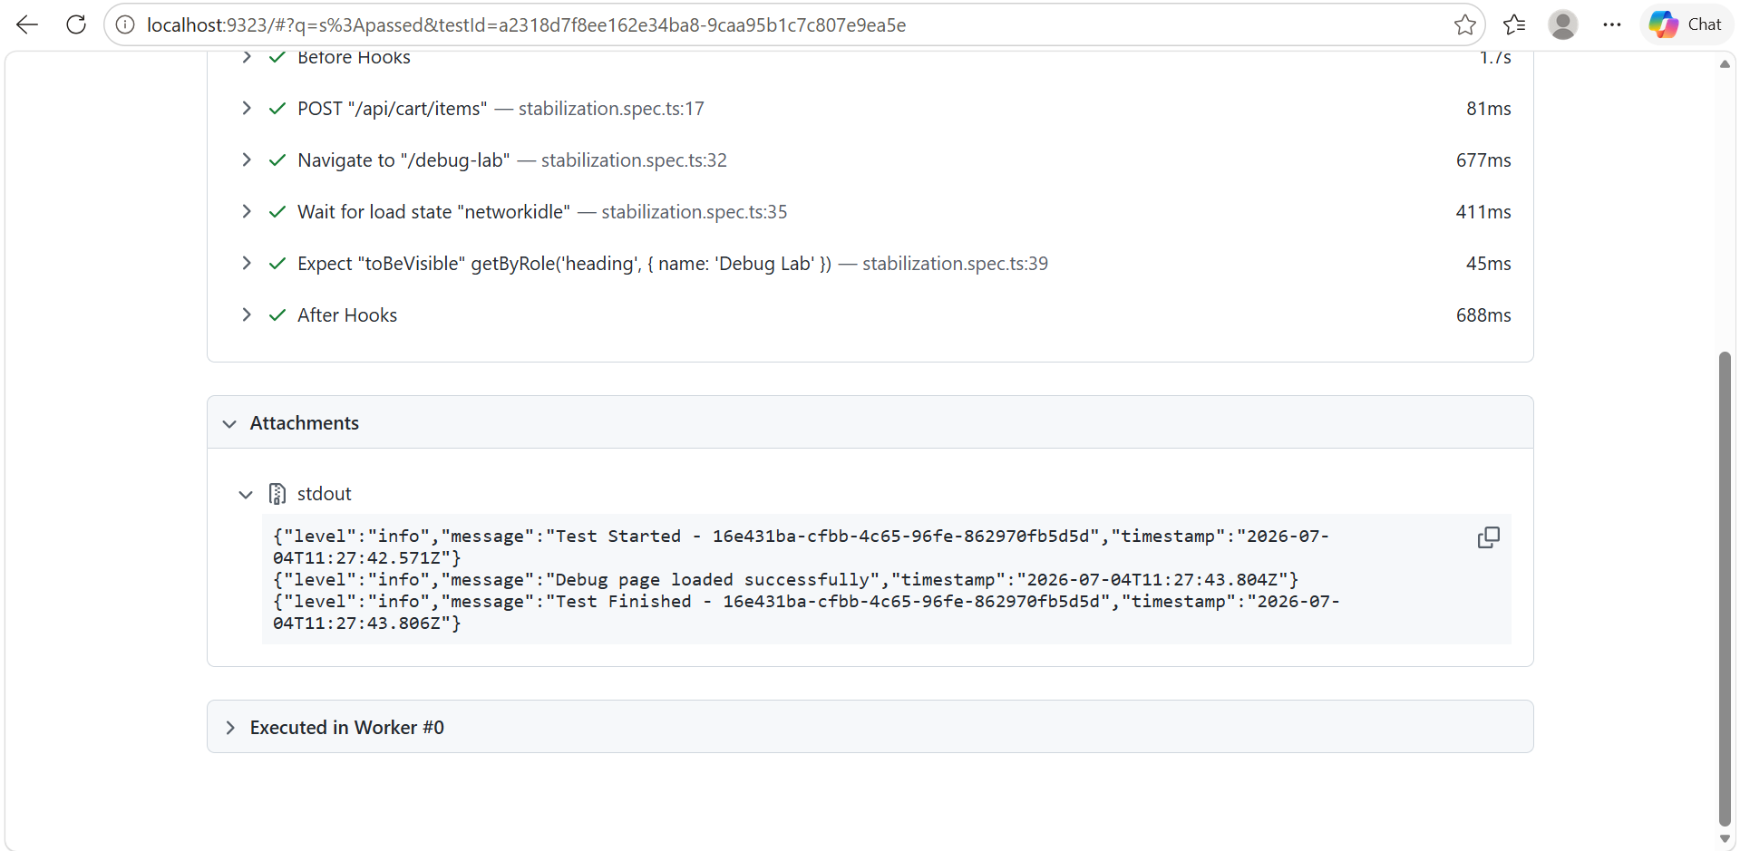

I assumed that opening the Debug Lab page would automatically call the /api/cart API.
However, that assumption was incorrect.
The Debug Lab page did not make a request to /api/cart when it loaded. Instead, it remained in the idle state and waited for the user to click the Refresh cart total button.
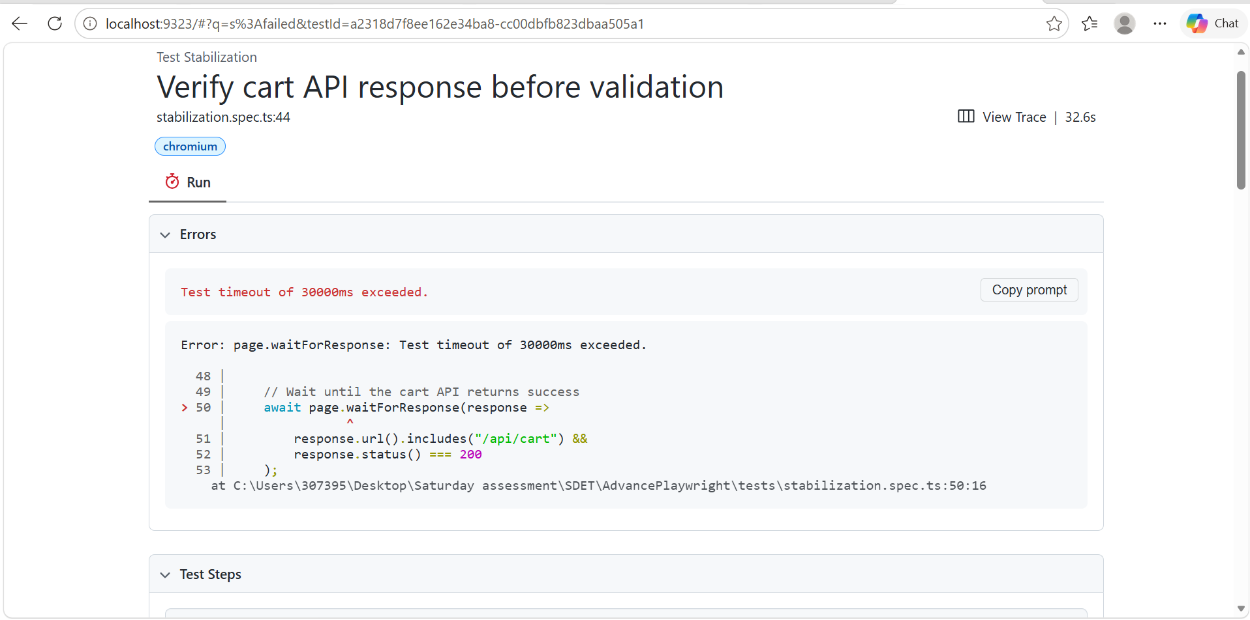
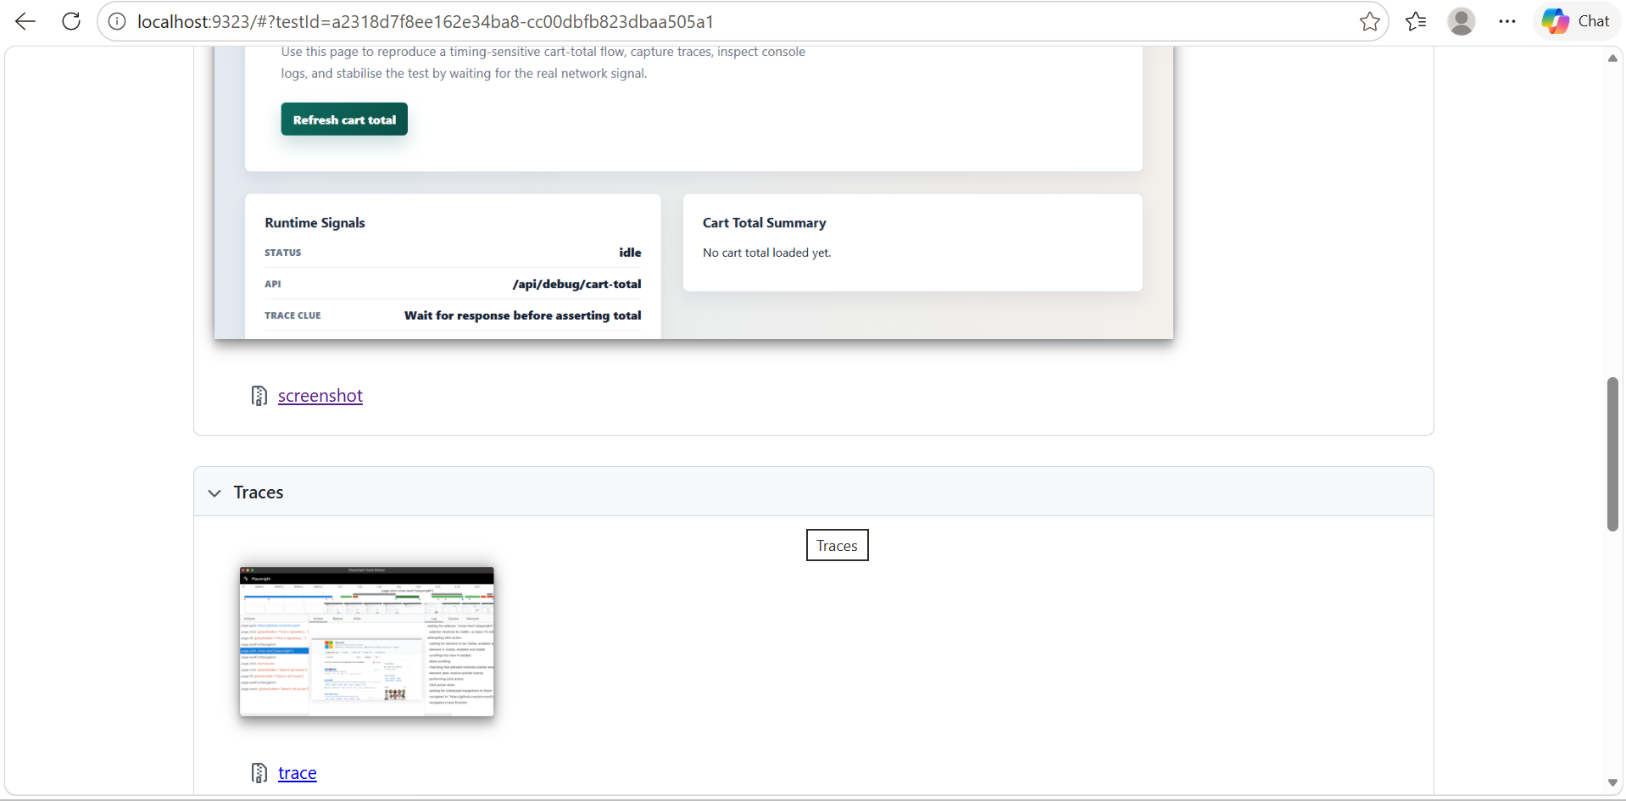

Test timed out while waiting for the cart API response.
Root Cause: The test waited for the wrong endpoint (/api/cart), and the Debug Lab page does not automatically trigger that request. The actual API (/api/debug/cart-total) is only called after clicking the Refresh cart total button.
Fix: Wait for the correct endpoint and trigger the network request by clicking Refresh cart total before asserting the UI.
This explanation aligns with the hint shown on the page itself: "Wait for response before asserting total."

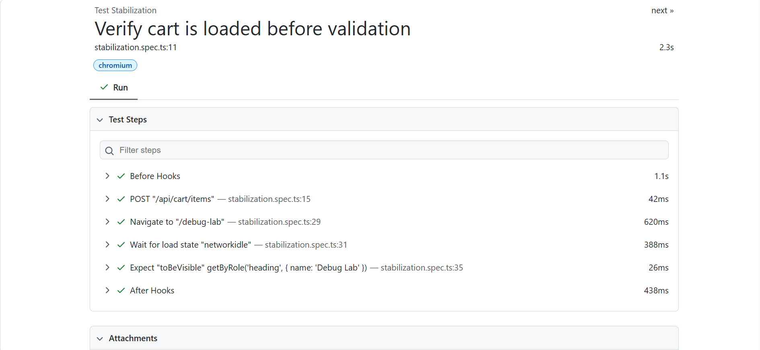

SRC
1.logger.ts
import winston from "winston";

export const logger = winston.createLogger({
level: "info",

format: winston.format.combine(
winston.format.timestamp(),
winston.format.json()
),

transports: [
new winston.transports.Console()
]
});

This file creates a Winston logger that is used throughout your Playwright project to generate structured logs. Instead of using console.log(), it provides timestamps, log levels, and JSON-formatted output, making debugging much easier.

2.refund.api.ts
This file is the API helper file for your refund automation. Instead of writing API calls inside every test, you have created reusable functions. This follows the DRY (Don't Repeat Yourself) principle and keeps your test cases clean and maintainable.

